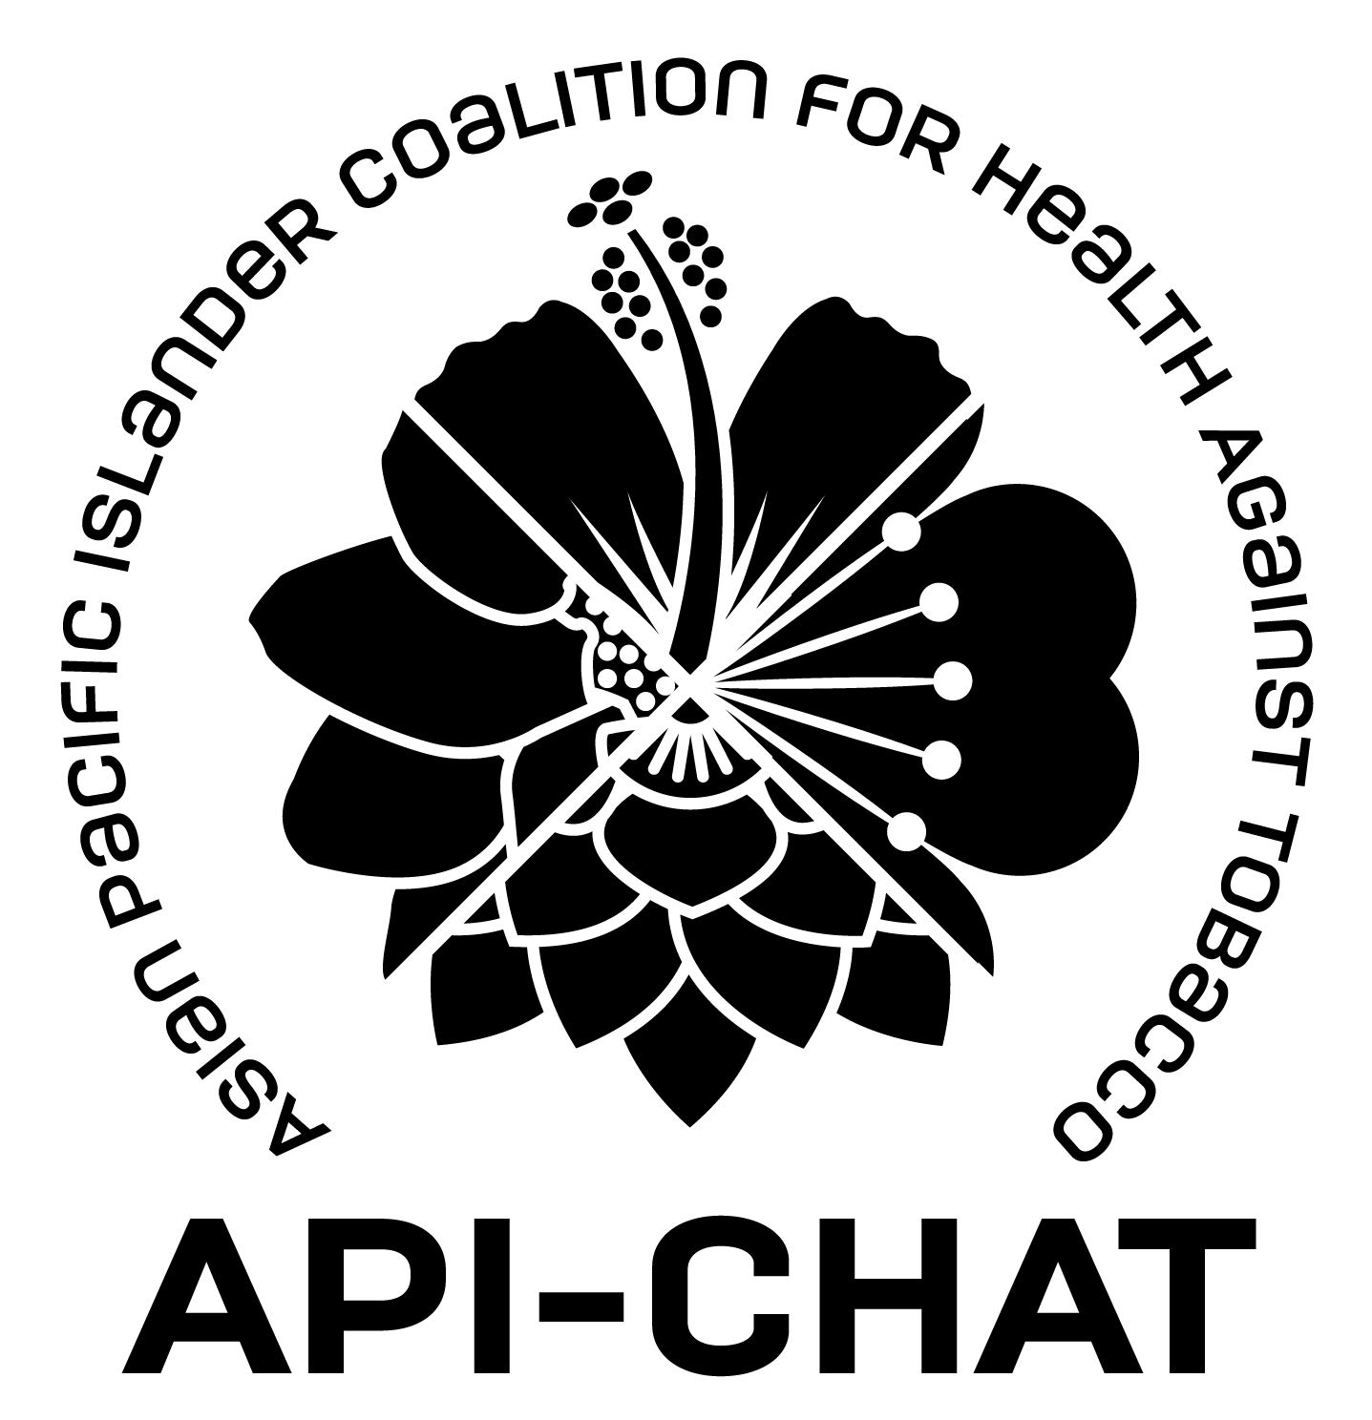
Paid internship opportunity
Project API-CHAT

Targeting racial minorities, children, women, and the LGBTQ population has always been a central pillar of Big Tobacco’s business strategy – and this includes Asian and Pacific Islander communities. Through deceptive marketing, higher tobacco retailer density and lower prices in communities of color, and the creation of culturally familiar vaping products, there has been an explicit effort to hook API communities on nicotine. Clean Air De Anza (CADA) is a paid internship for young community organizers and health advocates who want to do something about it right here in your community. We are building a group of Young Adult Leaders to take on big problems. Help us fight Big Tobacco with organizing campaigns right here on De Anza’s campus. While we encourage students from Asian and Pacific Islander communities to join us, we accept and welcome people from all backgrounds in our project.

Qualifications:

- Passionate about public health and social change
- Current or incoming student at De Anza college (any major and any number of credits)
- Ideally available on Wednesdays from 2:30 – 4:00 for meetings during the Fall 2019 term.

Facts:
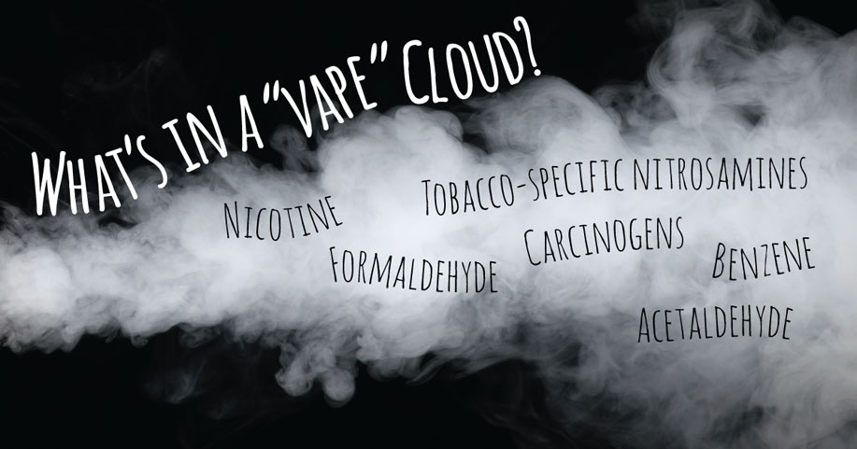
- The tobacco industry owns a majority stake in every existing vape company
- Big Tobacco, whose product is the leading cause of preventable death, targets communities of color and low-income populations.
- Second-hand smoke is the 3rd leading cause of preventable death in the U.S.
- Research shows that teens and young adults who start vaping are between 3-7 times more likely to start smoking combustible tobacco than those who don’t vape.

Our team will:
- Learn about public health perspectives and leadership skills.
- Build an organization of students to change campus and city-level policies with collective power.
- Develop outreach tools and events, PSAs, public health surveys, and gather endorsements from the school administration.
- Earn money through a stipend that comes out to about $15-$20 per hour.

E-Mail Owen at API-CHAT@bacr.org to get an application or learn more, or visit www.bacr.org/api-chat

